99 Things to See and Do in Dundee

A crowdsourced guide by people who know and love the city.

Thanks for picking up a 99 Things guide! Created in collaboration with people who live here and love it, this crowdsourced guide is produced by Creative Dundee – it’s full of playful, free, accessible, cultural, green and mood lifting things to see and do. A big thank you to everyone who shared recommendations for our seventh edition!

Dundee is a great size for exploring on foot, by bike or by bus, and our central location makes it easier to travel here and make day trips to nearby places, too. We hope you enjoy your time in the city, whether you’re visiting or using our guide to find something new.

Creative Dundee centres creative practitioners and communities as powerful catalysts for collective good. Visit us online for news, events and city updates, and sign up for our News Mail Out to receive a monthly round-up of brilliant things happening across Dundee.

www.creativedundee.com / @creative_dundee

This guide was produced by Creative Dundee with support from UNESCO City of Design, Dundee; Dundee: One City, Many Discoveries; and V&A Dundee.

Illustration: Freya Allan
Design: Agency of None
Printing: Bruce Clark Printers
Published July 2026



Across Dundee: Map
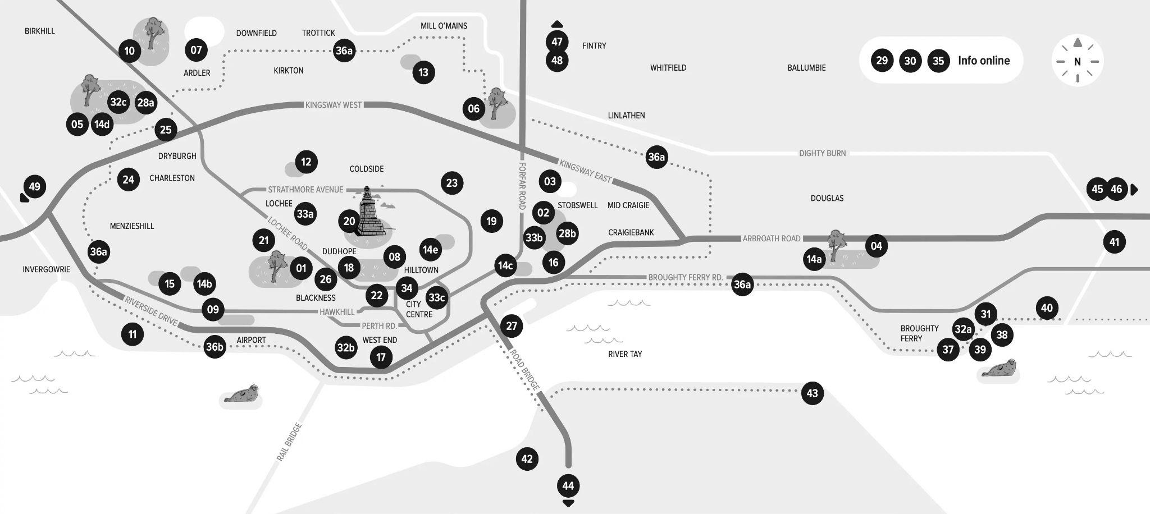

Dundee map link

Across Dundee

Parks and gardens

Dundee is Scotland’s sunniest city, with lots of green and growing spaces to wander to and through, whatever the weather. Some include (1) Balgay Park, with Mills Observatory, Victoria Gardens and great views. Stop by the grand pavilion in (2) Baxter Park, wave to the swans, ducks and model boats at (3) Swannie Ponds, and don’t miss the cherry blossoms at (4) Dawson Park! At (5) Camperdown Country Park you’ll find a tree trail and the Wildlife Centre, and (6) Caird Park is home to Mains Castle, Den o' Mains woodland and the Regional Performance Centre sports hub. Walk around the reservoir at (7) Clatto Country Park and watch the skaters at (8) Dudhope Park. Experience landscapes from around the world at (9) Dundee Botanic Gardens and the wildlife and walking routes of (10) Templeton Woods, then keep your eyes peeled for local flora and fauna at nature reserves, including (11) Riverside, (12) The Miley and (13) Trottick Mill Ponds.

Find Dundee’s wonderful community garden network across the city, including (14a) Duntrune Community Gardens, (14b) Ninewells Community Garden, (14c) Tayview Community Garden, (14d) Campy Growers and (14e) The Maxwell Garden. Visit growdundee.blog to discover urban orchards, Wee Forests, allotments and foraging spots!

Explore more

Admire the impressive exterior of (15) Maggie’s Centre, designed by renowned architect Frank Gehry. Discover local transport pioneers at (16) Dundee Museum of Transport, and visit (17) Dundee Science Centre for interactive learning. Join a lunch-club or class at (18) Bharatiya Ashram Dudhope Multicultural Centre and (19) Dundee International Women’s Centre. Don’t miss Dundee’s ultimate view – head to the top of (20) The Law and experience a glorious panorama of the city, Perthshire, Angus, Fife and the Tay.

Get active with (21) Ancrum Outdoor Centre, (22) Avertical World, (23) Bloc10 Bouldering, (24) Change Centre Dundee, (25) Dundee Ice Arena, (26) Heart Space and (27) Wild Shore Dundee, or join a (28a) Camperdown parkrun or (28b) Baxter Park junior parkrun. Explore together with (29) Girls Who Walk and (30) Feminist Bird Club Dundee, or take a dip with (31) Dundee Dookers. Wee ones can burn energy at play parks including (32a) Castle Green, (32b) Roseangle, and (32c) Camperdown's many play zones. Discover nooks and crannies through an Open/Close street art trail in (33a) Lochee, (33b) Stobswell or the (33c) City Centre. Get bike advice from (34) Dundee Cycle Hub or cycle sociably with (35) Critical Mass Dundee. The 26-mile (36a) Green Circular cycle route loops right around the city – did you know you can (36b) wheel or walk along the Tay (or over!) all the way from the airport to Broughty Ferry and beyond? Embrace seaside life in the Ferry – explore (37) Broughty Castle Museum then visit (38) Broughty Ferry Beach to spot dolphins and sailboats, or go for a swim in the Tay before warming up in (39) Bees Sauna. Wander along the Esplanade to find (40) Barnhill Rock Gardens then head to (and under!) the (41) Seven Arches Viaduct by the Dighty Burn.

Take a day trip

There’s more to explore just outside of Dundee! Take a trip across the bridge to (42) Newport-on-Tay, where you’ll find Forgan Arts Centre and Tatha Gallery, or head to (43) Tayport for the Larick Centre and a walk through the spectacular Tentsmuir forest and beach. Further around the (44) North East Fife coast you can visit St Andrews, Craigtoun Country Park, Cambo Gardens, Kingsbarns Beach and the fishing villages of the East Neuk – make a stop at Bowhouse for a weekend market. Explore beautiful beaches along the (45) Angus coast from Monifieth and Carnoustie up to Lunan Bay and St Cyrus, with the stunning Arbroath Cliffs in between. Go to (46) Arbroath for the Signal Tower Museum and the house and gardens of Hospitalfield, alongside their contemporary art programme. Check out (47) Forfar for the Meffan Museum & Art Gallery and Forfar Loch. For (48) walks in Angus and Perthshire, try the Angus Glens, Backmuir Woods, Monikie Country Park, Edzell’s Blue Door Walk and the Hermitage at Dunkeld. Don’t miss stunning views from the hills of the Sidlaws, and visit the Cateran Ecomuseum – a museum without walls. UNESCO City of Craft (49) Perth is home to Perth Museum, Perth Art Gallery, Perth Theatre and Concert Hall, Perth Creative Exchange and more – go for a wander by the Tay around Branklyn Garden and the Norie-Miller Walk, or enjoy the view from the top of Kinnoull Hill.

City Centre: Map
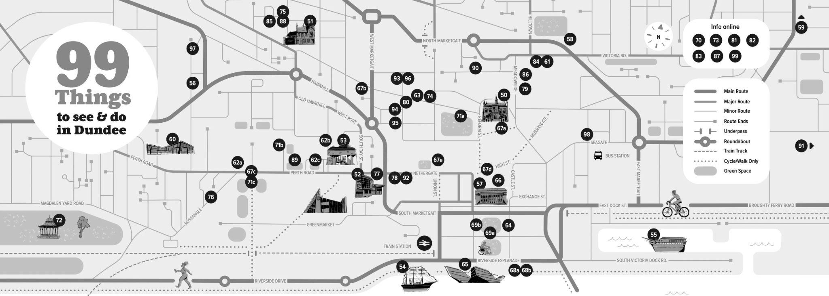

City Centre map link

City Centre

Take in the city’s creativity

Explore fascinating insights into Dundee at the (50) McManus Art Gallery and Museum, and see our jute textile history come to life at (51) Verdant Works Museum. (52) Dundee Contemporary Arts is home to galleries, a cinema, print studio and family creative space, and (53) Dundee Rep Theatre and Scottish Dance Theatre produce and show world-class performances. Step onboard (54) RRS Discovery to explore the famous polar expedition ship, then head along the Waterfront to (55) HMS Unicorn, Scotland’s oldest ship. Enjoy local and touring music, theatre and comedy at (56) Whitehall Theatre and (57) Caird Hall, and community productions at (58) The Little Theatre, while (59) Shaper/Caper throw shapes and have fun through critically-acclaimed performances. Support exhibitions by local and emerging artists at artist-run (60) Generator Projects, and take something home from art-vending machine (61) Volk Gallery. The University of Dundee hosts exhibitions in the (62a) Cooper Gallery inside Duncan of Jordanstone College of Art & Design, (62b) D’Arcy Thompson Zoology Museum and (62c) Tower Foyer and Lamb Galleries. See more art in the windows of (63) Nomas* Projects and billboard panels of (64) Sharing Not Hoarding. Whatever you do, don’t miss Scotland’s design museum, (65) V&A Dundee!

Go for a wander

Just a short walk from (66) City Square, several monuments nod to Dundee’s creative past – visit (67a) Oor Wullie, (67b) Bash Street, (67c) the Lemmings, (67d) Desperate Dan and Minnie the Minx. Find neighbours from colder climates commemorated through the (67e) Penguins outside the historic Old Steeple and (68a) Whale sculpture at the (68b) Urban Beach – don’t forget your bucket and spade! At (69a) Slessor Gardens you can celebrate the pioneering spirit of Dundonians with the (69b) Discovery Walk and wander through themed pocket gardens. (70) Public Art Dundee has free online trails to introduce you to 50+ artworks across the city. Pause for a moment of quiet contemplation at (71a) The Howff, (71b) Geddes Quadrangle, (71c) Seabraes Viewpoint (with mini bandstand!). Visit the (big!) bandstand at (72) Magdalen Green and explore Dundee’s history with (73) DD Tours. Find indie shops, restaurants, cafes and bars across the city, especially around Westport, Perth Road, Exchange Street and the Ferry.

Make, learn and create

If you’re looking for ways to get creative, try (74) Double Door Studios, (75) Dundee Ceramics Workshop, (76) Dundee Art Society and (77) DCA Print Studio. Initiatives like (78) The Wardrobe, (79) ScrapAntics Community Space and (80) Art Angel, (81) Tayside Healthcare Arts Trust, (82) Comics Youth, (83) Dundee Changemakers Hub build community around creativity, sustainability and wellness. Visit Dundee’s brilliant libraries, including (84) Central Library, for varied programmes and resources, and drop in to the (85) ScrapStore and the (86) Community Toolbox at Wellbeing Works to borrow, reuse and recycle.

Creative spaces, live music, festivals and events

Here are a few of the organisations and events that keep the city creative as the UK’s only (87) UNESCO City of Design. (88) Wasps Studios hosts over 75 artists and makers at Meadow Mill. (89) University of Dundee, (90) Abertay University and (91) Dundee & Angus College all have leading art and design courses, with degree shows in spring.

See local and touring bands at (92) Live House (93) Hidden, (94) Beat Generator and (95) Clarks on Lindsay Street, and head to (96) Music Hall, (97) Canvas and (98) POUT for a night out.

The city is home to lots of festivals and events – some to check out include: Dundee Month of Design; Dundee Design Festival; Dundee Zine Fest; DeeCon; Dundee Play Festival; Doof in the Park; Dundee Book Festival; dundee radio club Listening Fest; Dundee Fringe; Dundee Dance Event; Dundee WestFest; Dundee Pride; Dundee Music Festival; Dundee Graffiti Jam; Rep Stripped; Arcadia; Discovery Film Festival; Upstart: Creative Careers Festival; Eid in the Park; Dundee Science Festival; Dundead Horror Film Festival; Dundee Hooley; Broughty Ferry Gala Week; Dundee Get Together; 16 Days of Activism; Doors Open Days; Dundee Jazz Festival; and Christmas in Dundee.

If you’re planning a visit and have questions about accessibility, try peer-review sites Euan’s Guide and AccessAble – two online databases where disabled people can share experiences and recommendations.

To account for changes and updates, search online for up-to-date information on recommendations featured in this guide.

(99) Creative Dundee! Discover even more creativity around the city by exploring our website, joining our Amps network, and coming to our events such as PechaKucha Night Dundee!

We believe in the power of culture and creativity in driving positive change, with justice, wellbeing and sustainability at the heart of our social purpose. Since 2008 we’ve been shouting out the incredible creative talent across Dundee and beyond, fostering more connected communities and sparking inspiring new collaborations and opportunities.

Get involved to enable us to do more – and partner with us to imagine, act and benefit people and our place.

Your support helps us collectively amplify and connect creativity in Dundee. Find out more: www.creativedundee.com.

Support us by supporting Amps! Whether you’re a creative freelancer, student, business, organisation or someone who’s simply keen to take part, Amps is our network that’s open to all.

